Spectral coherence: AUDUSD and USDCAD
Method 21 / daily log returns / Welch magnitude-squared coherence / Alpari D1 full available history

Study setup
Logical pair: AUDUSD , USDCAD
Broker symbols: AUDUSD_i , USDCAD_i
Snapshot: 2026-11-03_majors_alpari_D1
Timeframe: D1
Matched return window: 1999-01-05 to 2026-11-02 (UTC bar dates)
Matched return count n: 7204
Dropped unfinished last bar dated 2026-11-03 UTC after a tick-volume check against the prior complete day.
Welch: fs=1.0, nperseg=256, noverlap=128, window=hann, detrend=constant
Headline: gamma^2 nearest f=1/5; also 1/21 and 1/63
Complete matched rows (Excel): AUDUSD-USDCAD_Spectral_D1.xlsx
Complete matched rows (HTML table): AUDUSD-USDCAD_Spectral_D1_data.html

Method carried forward
Magnitude-squared spectral coherence gamma^2(f) measures shared linear power between matched daily log returns of close, ln(close_t / close_t-1), at each frequency f (cycles per day). Quotes are not inverted. Welch settings are frozen: fs=1, nperseg=256, noverlap=128, window=hann, detrend=constant. Headline is gamma^2 at the frequency bin nearest f=1/5 (five-day cycle from the formula sheet). Also reported: gamma^2 nearest f=1/21 and f=1/63, mean gamma^2 over the frequency grid, and phase of the cross-spectrum at the 1/5 bin. Coherence is unsigned (0 to 1); phase carries timing. Same-sample Pearson r is a side check only. This is not causation and not a trading signal.

Results (headline)
gamma^2 near 1/5: 0.371376
bin f (1/5): 0.199219
phase at 1/5 (rad): 3.119776
gamma^2 near 1/21: 0.487028
gamma^2 near 1/63: 0.460426
mean gamma^2: 0.437711
Pearson r: -0.647362

Target-frequency summary
period | target_f | f_bin | gamma2 | phase_rad
5 | 0.2 | 0.19921875 | 0.3713763 | 3.1197756
21 | 0.04761905 | 0.046875 | 0.48702846 | -2.9723305
63 | 0.01587302 | 0.015625 | 0.46042607 | -3.0961967

Conclusion
Headline gamma^2 near f=1/5 for AUDUSD and USDCAD: 0.3714 (bin f=0.199219, phase=3.1198 rad). At ~1/21: 0.4870; at ~1/63: 0.4604. Mean gamma^2 = 0.4377. Pearson r = -0.6474. This is frequency-domain linkage, not a trading signal.

Charts
Daily closes

Daily log returns

Spectral coherence gamma^2(f)
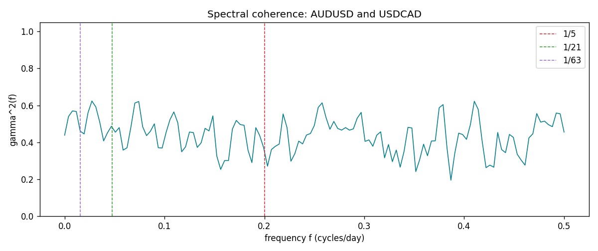

Data report
Matched rows and the coherence sheet are in the sibling Excel workbook named AUDUSD-USDCAD_Spectral_D1.xlsx. Embedding all rows as a Word table is impractical; this file holds column summaries and the first and last 15 matched rows.
Columns: time, AUDUSD_open, USDCAD_open, AUDUSD_high, USDCAD_high, AUDUSD_low, USDCAD_low, AUDUSD_close, USDCAD_close, AUDUSD_tick_volume, USDCAD_tick_volume, AUDUSD_spread, USDCAD_spread, AUDUSD_real_volume, USDCAD_real_volume, AUDUSD_log_return, USDCAD_log_return
Column summaries (matched calculation rows)
column | count | mean | std | min | 25% | 50% | 75% | max
AUDUSD_open | 7204 | 0.75193151 | 0.13526075 | 0.4785 | 0.6610425 | 0.731405 | 0.8086175 | 1.10284
USDCAD_open | 7204 | 1.2670146 | 0.16899756 | 0.9168 | 1.118975 | 1.298545 | 1.372225 | 1.6183
AUDUSD_high | 7204 | 0.7559812 | 0.13582551 | 0.4878 | 0.6647 | 0.734785 | 0.81467 | 1.10795
USDCAD_high | 7204 | 1.2719163 | 0.16895637 | 0.9336 | 1.123375 | 1.30394 | 1.3767575 | 1.619
AUDUSD_low | 7204 | 0.74787477 | 0.13457623 | 0.4775 | 0.6577 | 0.727495 | 0.8042 | 1.0975
USDCAD_low | 7204 | 1.2624553 | 0.16903522 | 0.9056 | 1.11435 | 1.293585 | 1.3678925 | 1.6102
AUDUSD_close | 7204 | 0.75197934 | 0.13524694 | 0.4786 | 0.6611975 | 0.731695 | 0.808875 | 1.10169
USDCAD_close | 7204 | 1.2670334 | 0.16897258 | 0.916 | 1.11848 | 1.298615 | 1.372515 | 1.6137
AUDUSD_tick_volume | 7204 | 77316.143 | 138115.43 | 109 | 5421.75 | 43310.5 | 71296.75 | 1234623
USDCAD_tick_volume | 7204 | 80846.476 | 147183.52 | 56 | 5511.25 | 40857 | 71531.75 | 1410818
AUDUSD_spread | 7204 | 30.823709 | 16.885829 | 0 | 13 | 30 | 50 | 50
USDCAD_spread | 7204 | 23.505275 | 18.28107 | 0 | 9 | 17 | 40 | 60
AUDUSD_real_volume | 7204 | 5.2399076e+09 | 1.2535442e+11 | 0 | 0 | 0 | 0 | 3.811512e+12
USDCAD_real_volume | 7204 | 1.8332738e+10 | 9.6584767e+10 | 0 | 0 | 0 | 0 | 2.5751613e+12
AUDUSD_log_return | 7204 | 2.007e-05 | 0.0075444 | -0.08602525 | -0.00386183 | 0.00027895 | 0.00414528 | 0.0806166
USDCAD_log_return | 7204 | -1.21e-05 | 0.00514438 | -0.03859748 | -0.00283637 | 4.97e-05 | 0.00272781 | 0.03436319
First 15 matched rows (selected columns)
time | AUDUSD_log_return | USDCAD_log_return
1999-01-05 | -0.00080418179 | -0.010131666
1999-01-06 | 0.011836351 | -0.0003306769
1999-01-07 | 0.0088650256 | 0.0015202092
1999-01-08 | 0.00031515916 | -0.0020495197
1999-01-11 | 0.0072213815 | -0.0035137769
1999-01-12 | -0.0048608485 | 0.0066194721
1999-01-13 | -0.0078902098 | 0.0045420214
1999-01-14 | -0.002696916 | 0.0069376546
1999-01-15 | 0.007123101 | -0.0056905671
1999-01-18 | 0.00094592471 | 0.00098344542
1999-01-19 | 0.0072225153 | 0.002748513
1999-01-20 | 0.0012507819 | -0.0059646885
1999-01-21 | 0.00078094498 | -0.0042823796
1999-01-22 | -0.012252745 | 0.0025057712
1999-01-25 | -0.0039591468 | 0.00085579808
Last 15 matched rows (selected columns)
time | AUDUSD_log_return | USDCAD_log_return
2026-10-13 | 0.0035007712 | -0.0046395653
2026-10-14 | -0.0015193215 | 0.0015184751
2026-10-15 | -0.0075447063 | -0.0036101503
2026-10-16 | 0.0033906408 | -0.0034322068
2026-10-19 | 0.0050859986 | -0.0018835331
2026-10-20 | 0.0034620426 | -0.0037066008
2026-10-21 | 0.0036066384 | -0.00084691787
2026-10-22 | -0.0012672558 | -0.0026307268
2026-10-23 | 0.0023765656 | 2.85545e-05
2026-10-26 | -0.0032032829 | 5.7106554e-05
2026-10-27 | 0.0016669876 | 0.0025379458
2026-10-28 | 0.0040915541 | -0.0038379274
2026-10-29 | -0.0040915541 | -0.00011436495
2026-10-30 | 0.0010102376 | -0.0010298736
2026-11-02 | -0.0049184984 | 0.00061519094
First 15 frequency bins
f | gamma2 | phase_rad | period_days
0 | 0.43825575 | 3.1415927 | inf
0.00390625 | 0.53959291 | 2.9226909 | 256
0.0078125 | 0.56995399 | 2.9810708 | 128
0.01171875 | 0.56700696 | 3.0212844 | 85.333333
0.015625 | 0.46042607 | -3.0961967 | 64
0.01953125 | 0.44531476 | -3.0535658 | 51.2
0.0234375 | 0.56029606 | -3.0777184 | 42.666667
0.02734375 | 0.62380336 | 3.1107764 | 36.571429
0.03125 | 0.59170911 | 3.1328305 | 32
0.03515625 | 0.50968871 | -3.0585982 | 28.444444
0.0390625 | 0.40785922 | 3.0509681 | 25.6
0.04296875 | 0.45227872 | -3.0814048 | 23.272727
0.046875 | 0.48702846 | -2.9723305 | 21.333333
0.05078125 | 0.45477205 | -2.9935098 | 19.692308
0.0546875 | 0.47973025 | -2.8986541 | 18.285714

